**ECE320 Lab 1**

| **Irene Suah Lee** | **Student number: 1003180149** |
| --- | --- |
| **Laura He** | **Student number: 1003893637** |
| **Songeun You** | **Student number: 1003815794** |

**Lab Section: PRA0107**

# **3.2 Determination of the Characteristic Impedance ZL**

*[ 3 ] Sketch of the waveform at point C when the line is terminated in 𝑍0.*

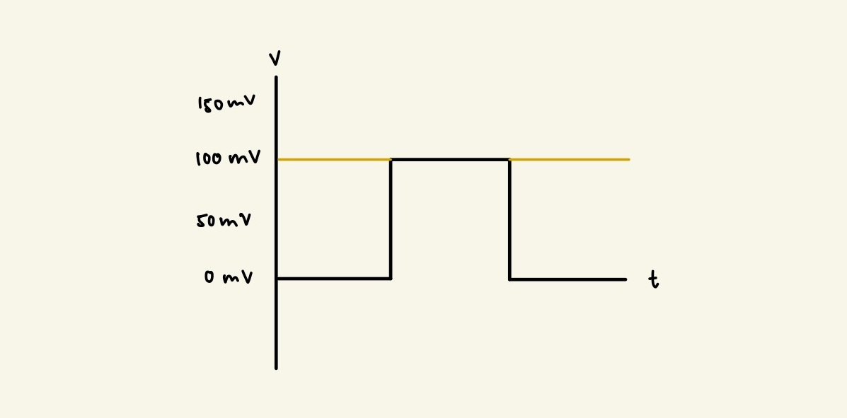

**Figure 1. Waveform at Point C when line is terminated at Z0**

*[ 2 ] 𝑍0 found using the variable load.*

The signal at point C shows no reflection when varing the terminating resistance ZL  = 50Ω. Thus, Z0 = 50Ω as the transmission line is matched and shows no reflection when ZL = Z0

# **3.3 Determination of the Characteristic Impedance using 𝑣1(𝑡,0)/𝑖1(𝑡,0)**

*[ 5 ] 𝑍0=𝑣1(𝑡,0)𝑖1(𝑡,0)calculated using Ohm’s law and measured voltages.*

From the waveform, we measured 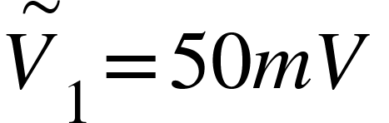and 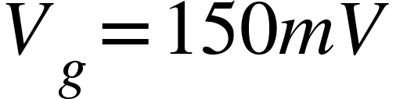. Given the value R = 100Ω, = 1mA. Thus, .

# 

# 

# 

# **3.4 Observation of Travelling Waves**

*[ 5 ] Measurement 𝑣 vs 𝑡 graphs at C, D, E, and F for𝑅L= 50 Ω.*

The 𝑣 vs 𝑡 graphs at points C, D, E, and F for RL= 50 Ω can be seen below:******

**Figure 2 (Port C) Figure 3 (Port D)**



**Figure 4 (Port E) Figure 5 (Port F)**

*[ 3 ] Recorded time delay ∆𝑡 at points D, E, and F relative to the input signal.*

The recorded time delays ∆𝑡, at points C, D, E, and F relative to the input signal:

| Port | ∆𝑡 (ns) |
| --- | --- |
| C | 0 |
| D | 120 |
| E | 240 |
| F | 360 |

**Table 1. Recorded time delays at points C, D, E, F**

**3.5 Determination of Velocity of Propagation**

*[ 2 ] Calculated average velocity of propagation 𝑣𝑎𝑣𝑔 and relative permittivity 𝜀𝑟.*

𝑣𝑎𝑣𝑔 = 90m / 360ns = **250 000 000 m/s**

𝜀𝑟 = 9/6.25 = **1.44**

*[ 10 ] Theoretical bounce diagram (2 marks) and corresponding 𝑣 vs 𝑡 graphs at C, D, E, and F (2 marks each). Compare with Section 3.4 measurement results.*

The time delay ∆𝑡 from the corresponding graphs are the same as the time delay measured in the section 3.4. In addition, the theoretical V(t) plots closely match the graphs measured in 3.4.

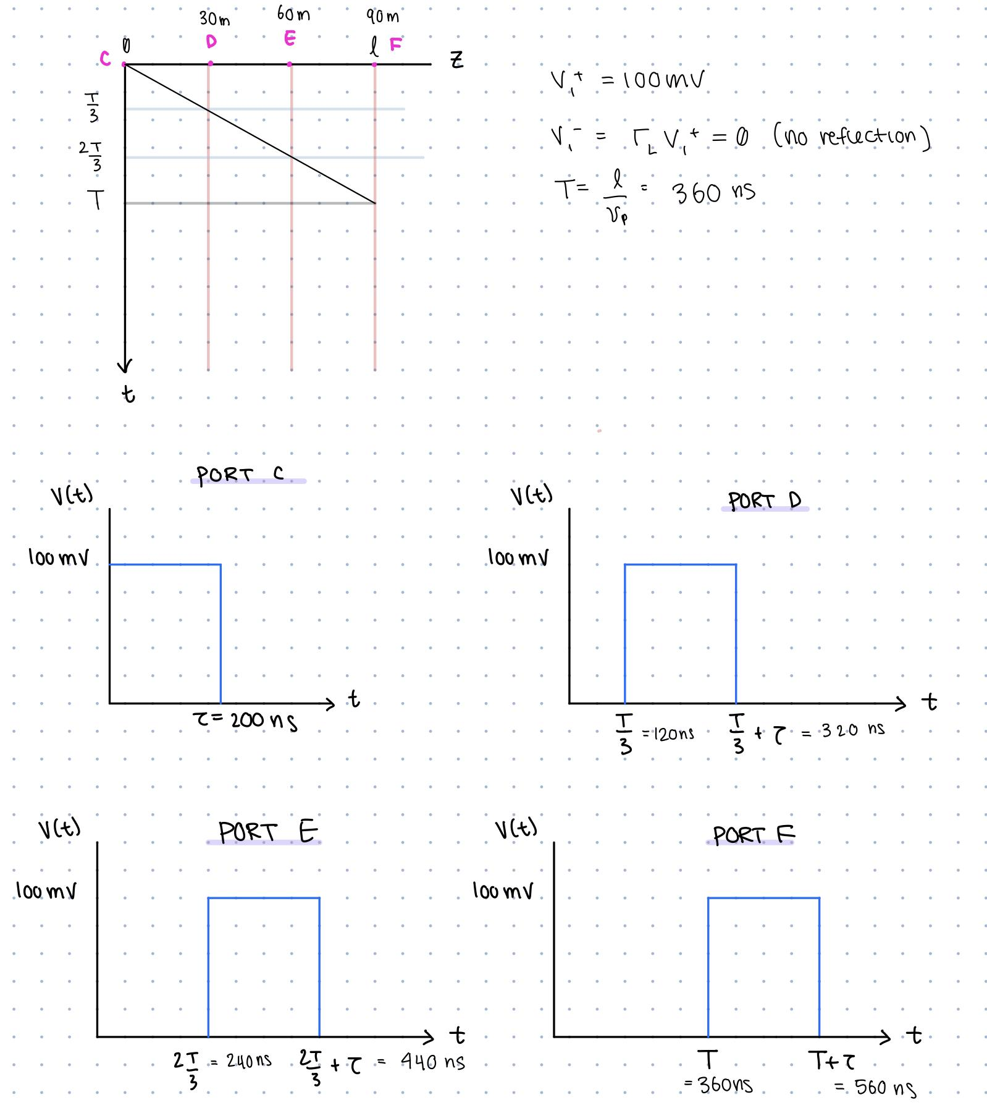

**Figure 6. Bounce Diagram and corresponding v vs t graphs at C, D, E, F**

# **3.6 Simple Reflection**

*[ 1 ] Compare calculated and measured ΓL.*

**Calculated:**

ΓL = (ZL - Z0) / (ZL + Z0) = (100mV - 50mV) / (100mV + 50mV) = 50mV / 150mV = **0.333**

**Measured:**

ΓL = V- / V+ = 30mV/100mV = **0.3**

*[ 4 ] Measurement 𝑣 vs 𝑡 graphs at C and F for 𝑅L= 100 Ω.*



**Figure 7. Graph F is identical but doesn’t have V2+ from the reflected wave.**

*[ 2 ] Discuss the relationship between the pulses at C and F.*

When 0 < t < T, the pulses at C and F, V1C+ and V1F+, are equal to the input pulse V+ = 100 mV.

When T < t < 2T, the pulses at C and F experience interference due to the non-zero load reflection coefficient ΓL = ⅓ (from above). Since the reflection coefficient is positive, there is positive interference, and the voltages that are reflected back towards the generator, V1C- and V1F-, are greater than the voltages that were initially incident on the load (V1C+ and V1F+).

The reflection coefficient at the source, ΓS, is zero since the source resistance is equal to the characteristic impedance. Thus, there is no reflection voltage V2C+ and V2F+.

*[ 10 ] Theoretical 𝑣 vs 𝑑 graphs at 𝑡=𝑇/2, 𝑇, 3𝑇/2, and 2𝑇 where 𝑇 = pulse width.*

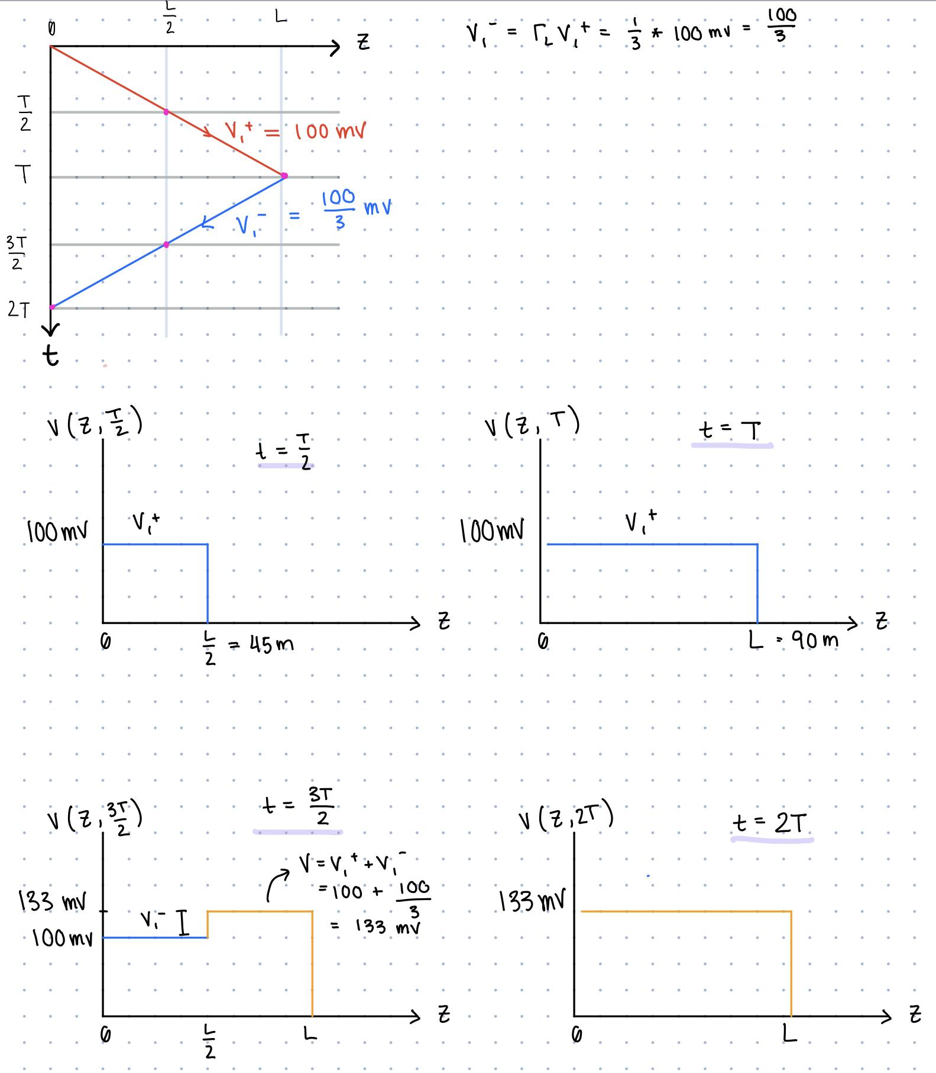

**Figure 8. Theoretical 𝑣 vs 𝑑 graphs at 𝑡=𝑇/2, 𝑇, 3𝑇/2, and 2𝑇**

*[ 2 ] Discuss the pulse propagation along the line with a mismatch at the load.*

If the load is mismatched from the transmission line, the pulse will reflect and propagate back through the line.

If there is a mismatch at the load, i.e. the load resistance and the characteristic impedance do not form a matched system, the load reflection coefficient ΓL will be non-zero. Thus, there will be a non-zero voltage reflected from the load to the source through the transmission line (V1-). This effect of the non-zero ΓL appears in the diagrams above as V1-.

**3.7 Multiple Reflections**

*[ 4 ] Measurement 𝑣 vs 𝑡 graphs at C and F for 𝑅source= (50 + 100) Ω and 𝑅L= 20 Ω for pulse widths of 𝑇 and 10𝑇.*

**Figure 9. Plot of v vs t at point C with pulse width T**

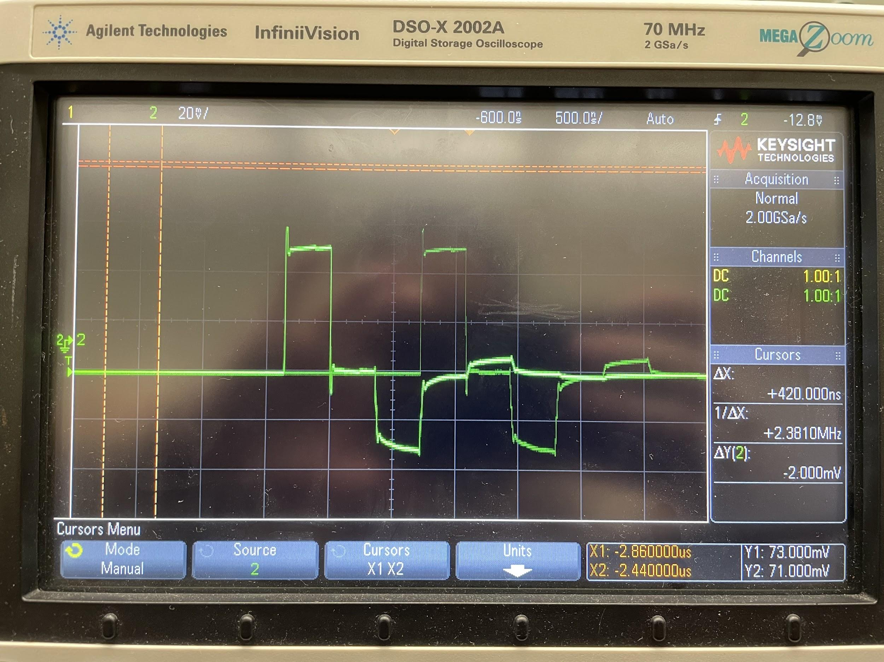

**Figure 10. Plot of v vs t at point F with pulse width T**

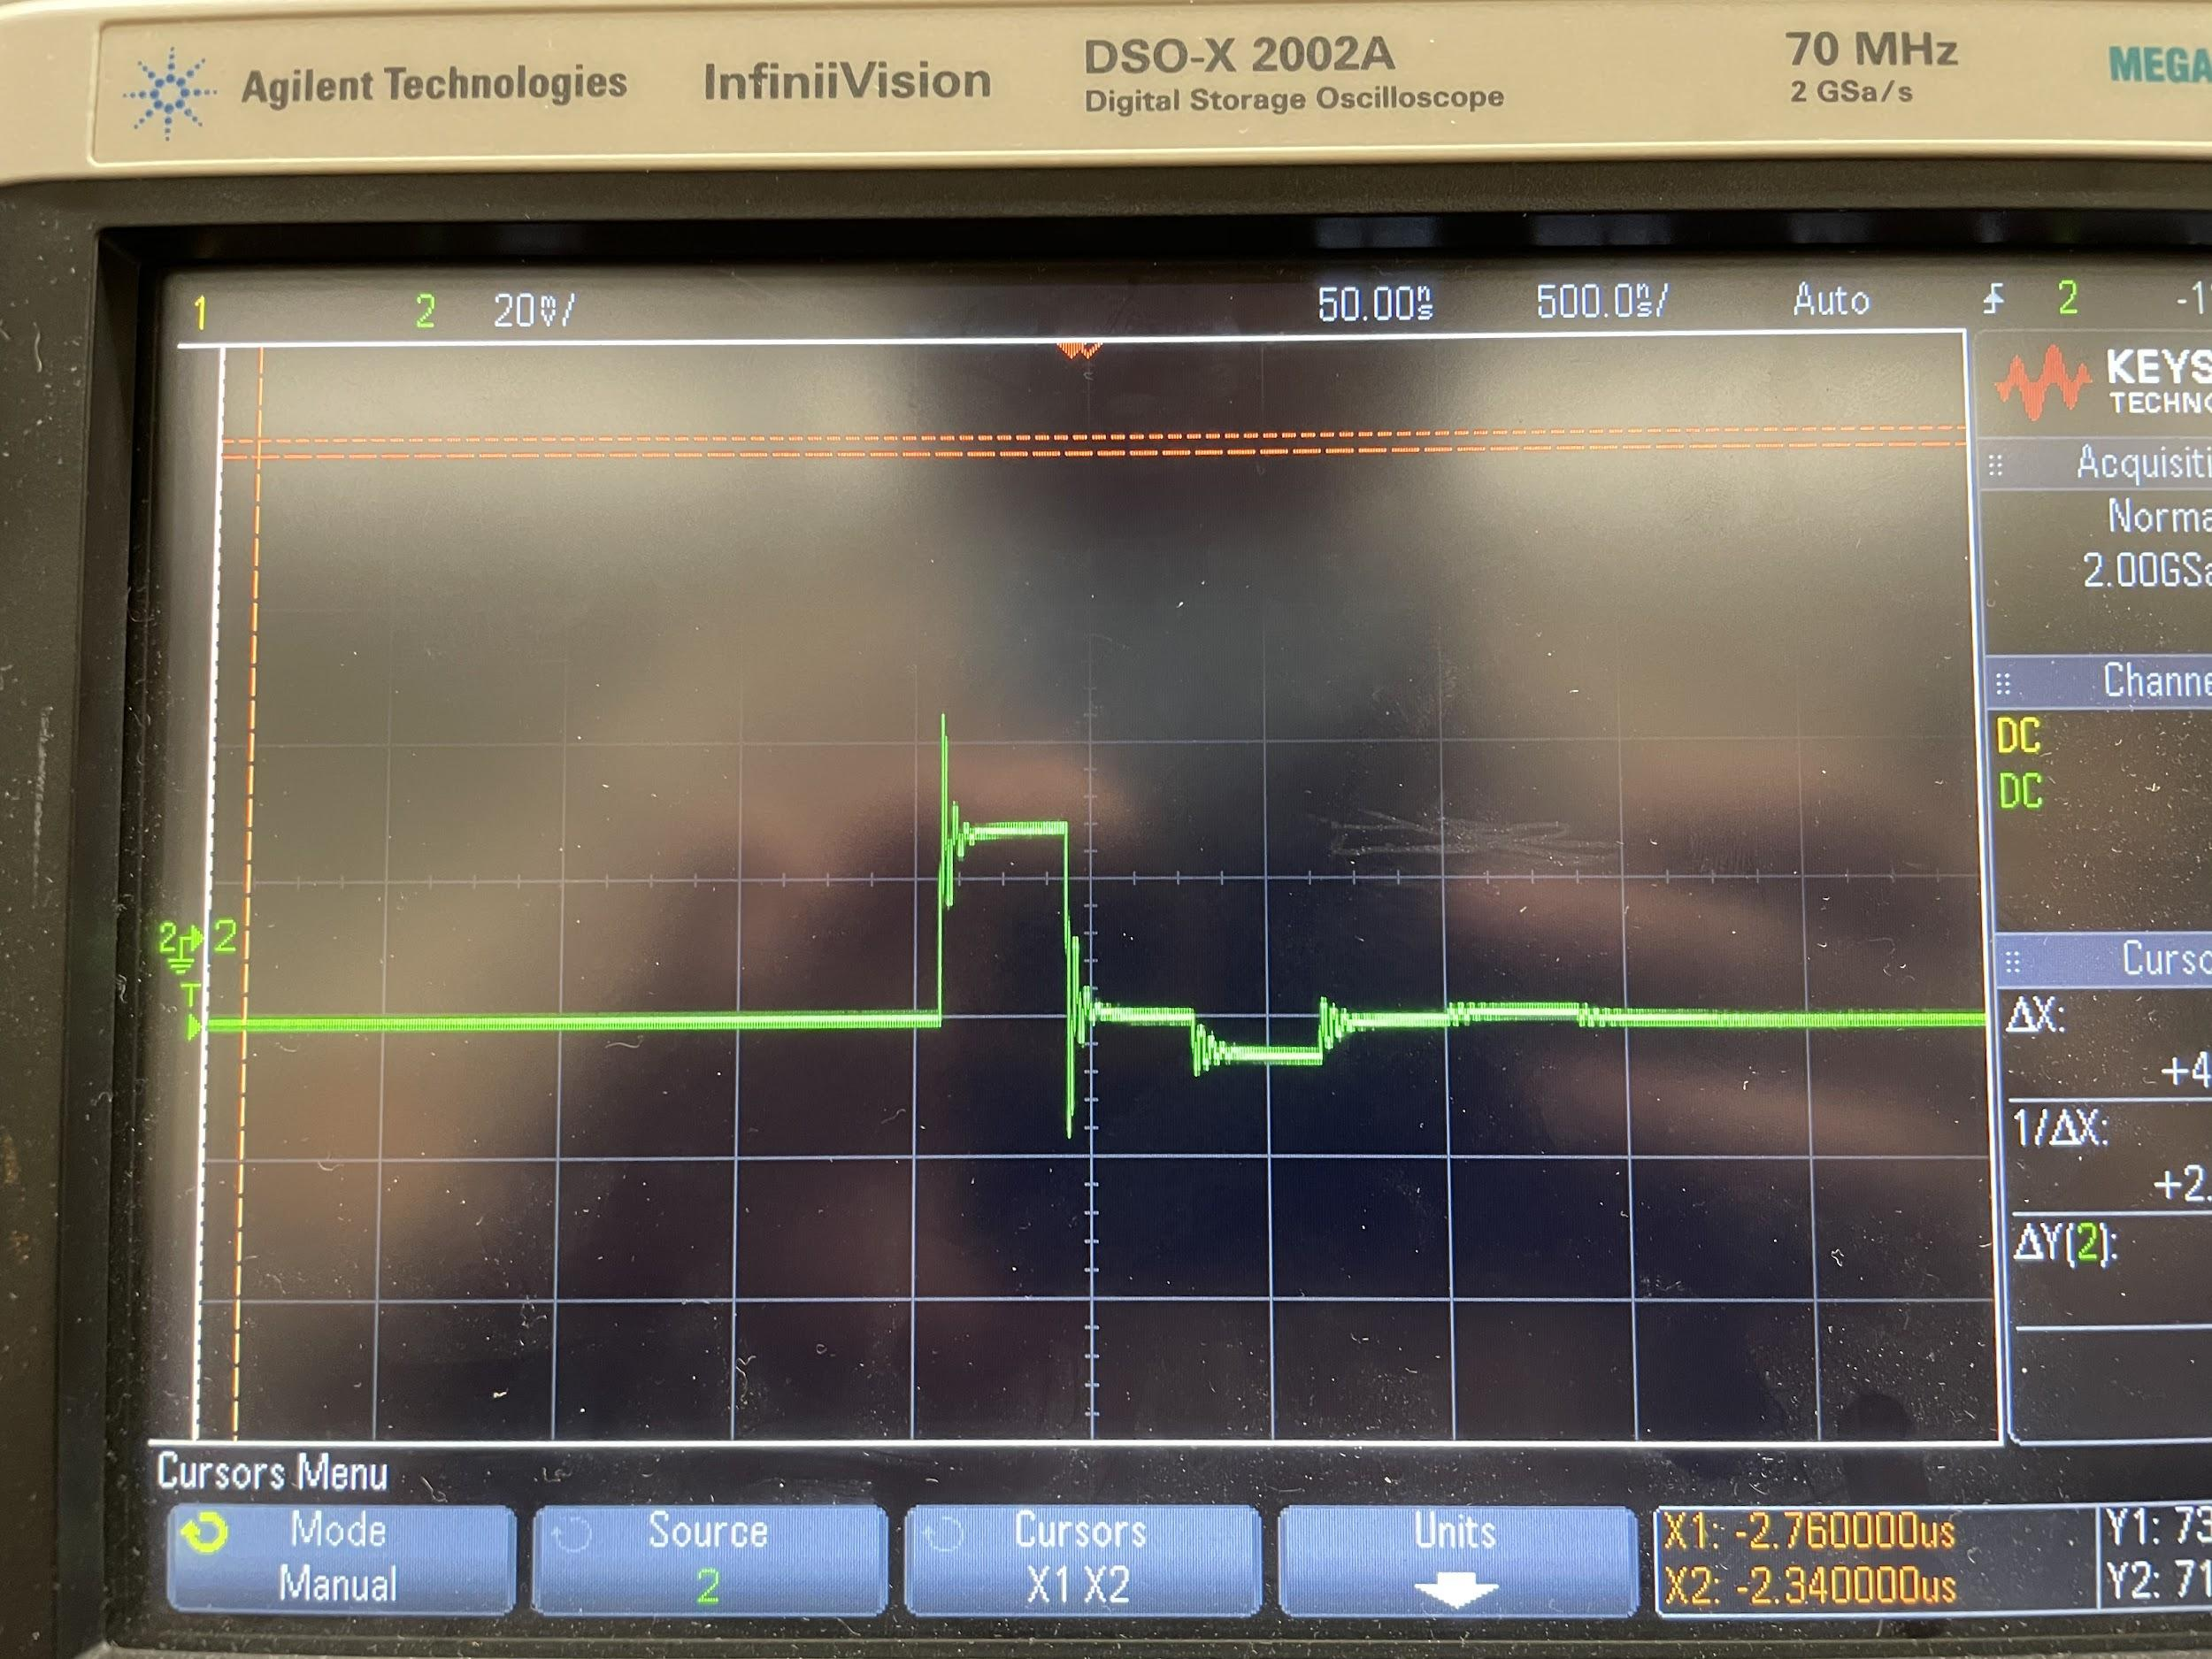

**Figure 11. Plot of v vs t at point C with pulse width 10T**

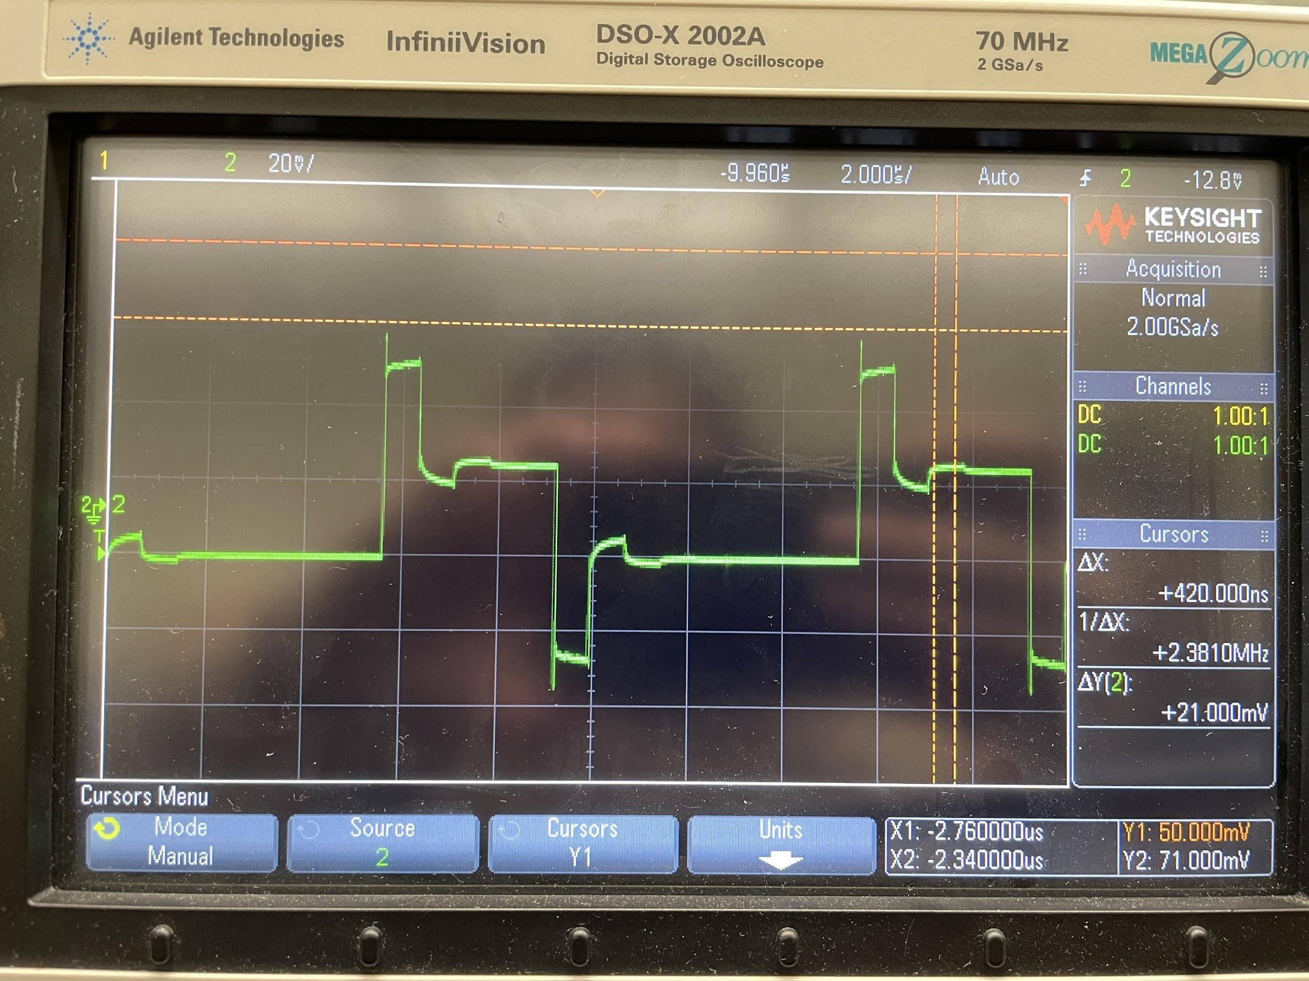

**Figure 12. Plot of v vs t at point F with pulse width 10T**

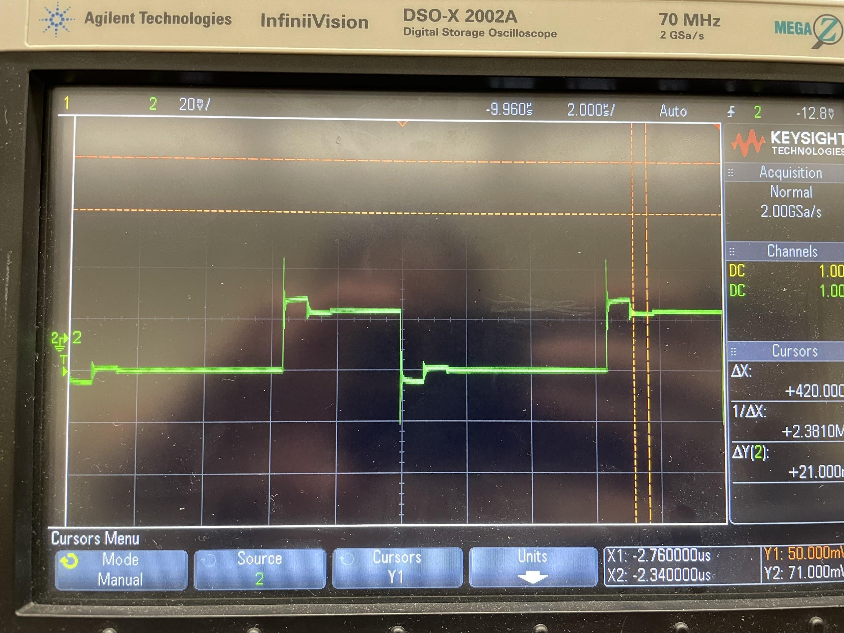

*[ 2 ] Calculated and measured ΓS and ΓL.*

**Calculated:**

ΓS = (ZS - Z0) / (ZS + Z0) = (150mV - 50mV) / (150mV + 50mV) = 100mV / 200mV = **0.5**

ΓL = (ZL - Z0) / (ZL + Z0) = (20mV - 50mV) / (20mV + 50mV) = -30mV / 70mV = **-0.429**

**Measured:**

ΓS = **0.62**

ΓL = **-0.462**

*[ 20 ] Calculate the corresponding theoretical bounce diagram for pulse widths of 𝑇 and 10𝑇 (5 marks each) and plot the theoretical 𝑣 vs 𝑡 graphs for each case at C and F(2.5 marks each).*

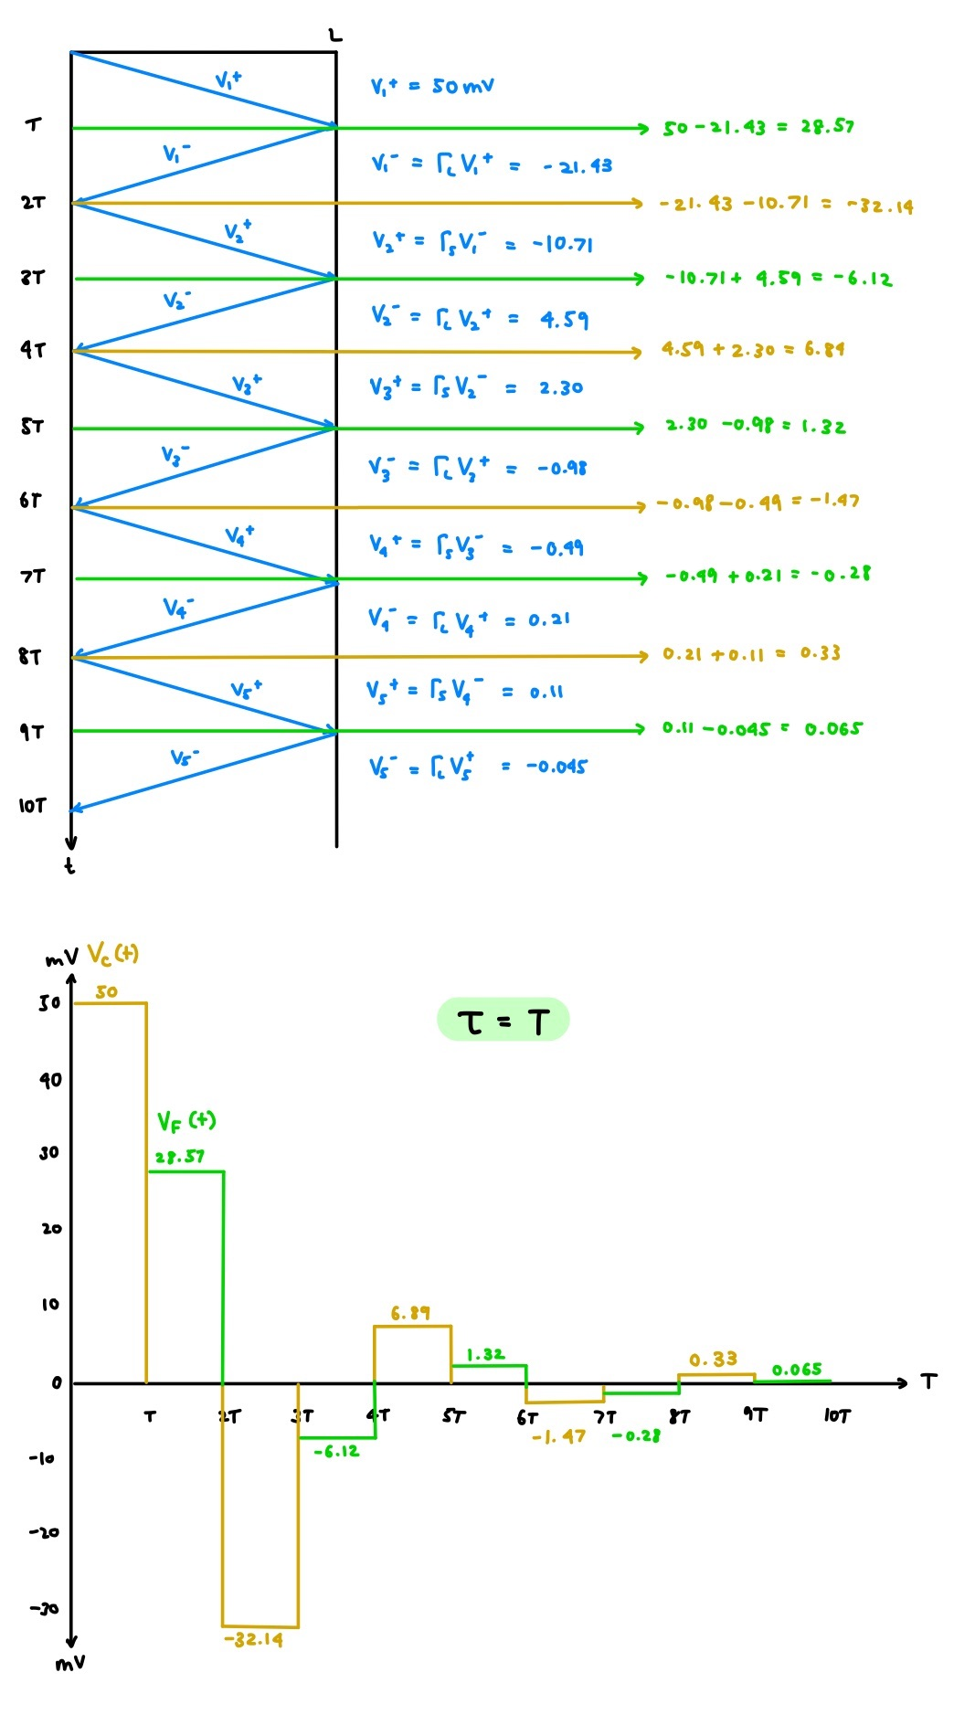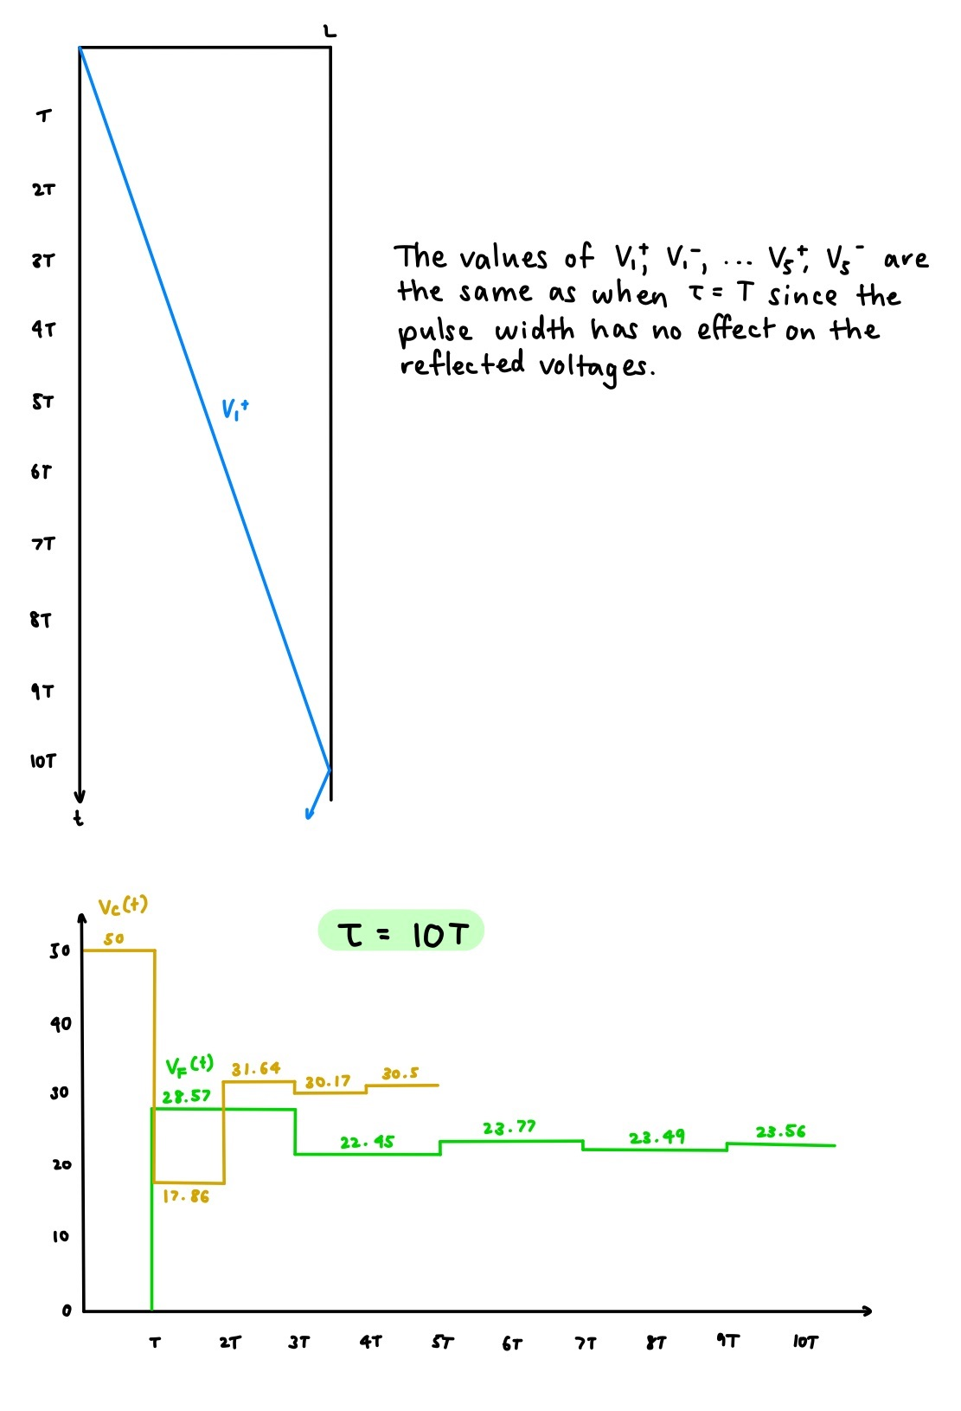

**Figure 13. Theoretical Bounce Diagram for pulse width of T and 10T and v vs. t graphs for each case at C and F**

**Calculated:**

ΓS = (ZS - Z0) / (ZS + Z0) = (150mV - 50mV) / (150mV + 50mV) = 100mV / 200mV = **0.5**

ΓL = (ZL - Z0) / (ZL + Z0) = (20mV - 50mV) / (20mV + 50mV) = -30mV / 70mV = **-0.429**

**C:**

V+ = **52mV**

**F:**

V+ = **28mV**

*[ 3 ] Discuss how the measured results compare to the theoretically calculated ones.*

The theoretical and calculated values of ΓL closely match each other (-0.429 theoretical vs -0.462 measured).

The theoretical and calculated values of ΓS differ much more (0.5 theoretical vs 0.62 measured).

# **3.8 Input Impedance and Transmission-Line Electrical Length**

*[ 3 ] Find three 𝑣1 minimum frequencies for the short circuit load.*

1.4, 2.8, 4.2 MHz

*[ 5 ] Explain why minimum voltages are obtained and discuss the effect on input current.*

From the voltage equation V(z) = VO+ * e-jβz (1 + ||ΓL||e-j2βz+jθr), it can be determined that the voltage changes as a result of exponent -j2βz+jθr. Specifically, a voltage minimum occurs when θr - 2βz = (2k + 1)π and k is an integer. For a short-circuited load, the reflection coefficient ΓL is -1 and the phase is fixed at θr = π. Thus, the only way to change the value of -j2βz+jθr is by varying β. Since β = ⍵/vP and ⍵ = 2πf, we can vary β by changing the frequency of operation of the transmission line.

The equation for the current I(z) is I(z) = VO+/ZO * e-jβz (1 - ||ΓL||e-j2βz+jθr). When the voltage is maximized, (1 + ||ΓL||e-j2βz+jθr) is maximized. Thus, (1 - ||ΓL||e-j2βz+jθr) is minimized and the current is at a minimum when the voltage is at a maximum.

If we look at the previous minimum frequencies we obtained, we can see that the minimum voltage appears approximately every 1.4MHz increase in frequency.

The input current is affected with the same periodicity, but is 90 degrees out of phase with the voltage maxima and minima. The current reaches its maximum when the voltage reaches its minimum.

*[ 3 ] Find three 𝑣1 minimum frequencies for the capacitive load.*

1.5, 2.8, 4.2 MHz

*[ 6 ] Discuss how and why the results for the short circuit and the capacitor are different.*

For a short circuited load, we know that θr is fixed to be θr = π. Thus, the voltage minimum for a short circuited load occurs when π - 2βz = (2k + 1)π, where k is an integer. However for a capacitative load, θr can be anywhere from π to 2π (lower half of Smith Chart). Specifically, θr(⍵) =2arctan(-j/⍵C) for C = 0.01𝜇F where θr is a function of ⍵. Therefore, the minimum frequencies found for the short circuit and capacitative load differ due to the capacitative load’s θr dependence on frequency whereas the θr for the short circuit is fixed to π.